iWell – Enhancing the Digital and Social Well-being in Schools
[PROJECT NUMBER: 2020-1-BG01-KA201-079041]

Newsletter 3
iWell TMP, 4th July 2022, Athens, KMOP  In early July 2022, partners managed to meet each other in person for the purposes of a productive face to face meeting. Since this was the first face to face meeting organized in the course of the project, partners were really happy to meet for the very first time. With the project’s official extension for six months, partners mapped out the project’s next steps and revised their schedules on the project’s implementations. In the following weeks, the project’s resources will be translated and soon the partnership will proceed to pilotings. The next partners meeting will take place in Cyprus, in autumn 2022.  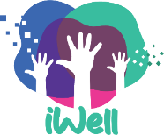  iWell LTTA, 4th – 8th July 2022, Athens, KMOP  Held in the beautiful city of Athens and organised by KMOP, the LTTA brought together 10 teachers from all partner countries who were introduced to the project and its achievements and given much time to test the resources developed (IO2 – iWell Curriculum; IO3 – iWell Mini-games and IO4 – iWell MOOCs for Teachers). Teacher-participants shared encouraging comments on the consortium attempts to enhance the Digital, Social and Emotional well-being in Schools, highlighting the importance of this project for schools, homes and societies. Teacher-participants were also introduced to the Adolescent Health NGO work on mental health during the mini-tour at the organisation’s premises. Beyond the busy schedule in getting aquainted with the project’s topic and works, teacher-participants visited the city of Athens and enjoyed a memorable cultural programme in an inspiring ambiance. | In this Issue  Welcome to iWell third newsletter with updates on the project works and achievements. In this issue, news regarding iWell TPM and LTTA in Athens will be shared and updates on the rest of the project’s works will be noted.
Further updates on iWell
The iWell Consortium has managed to draft the Mini-Games (IO3), the MOOCs resources (IO4) and the guidelines for the Toolkit with Policy & Practice Recommendations (IO5). Now the partnership is preparing the guidelines for the pilotings, following the translation of all resources that was completed during the summer months.
iWell partnership
- THE INSTITUTE OF TECHNOLOGY AND DEVELOPMENT FOUNDATION, BULGARIA (Leading Organisation];
- CARDET – CENTRE FOR ADVANCEMENT OF RESEARCH AND DEVELOPMENT IN EDUCATIONAL TECHNOLOGY LTD, CYPRUS;
- The Rural Hub CLG, IRELAND;
- CESIE, ITALY;
- INNOVADE LI LTD, CYPRUS; and
- KENTRO MERIMNAS OIKOGENEIAS KAI PAIDIOU, GREECE
Stay tuned with iWell
iWell Website:
https://iwellproject.eu/

iWell Facebook:
https://www.facebook.com/IWell-107756454714838/
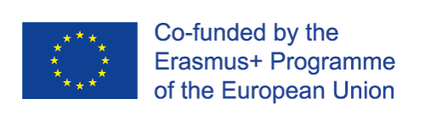
The European Commission support for the production of this publication does not constitute an endorsement of the contents which reflects the views only of the authors, and the Commission cannot be held responsible for any use which may be made of the information contained therein.

